EXP 6

6.1. let name = "John Doe";
let age = 30;
let isStd = false;
console.log("Name:", name);
console.log("Age:", age);
console.log("Is Student:", isStd);
console.log("Data type of name:", typeof name);
console.log("Data type of age:", typeof age);
console.log("Data type of isStudent:", typeof isStd);
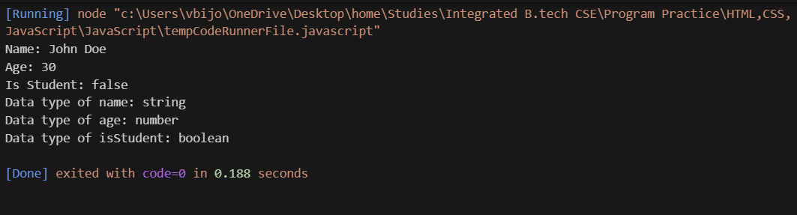
Output:

6.2. let a = 15;
let b = 4;
let s = a + b;
let diff = a - b;
let p = a * b;
let q = a / b;
let r = a % b;
console.log("Addition :", s);
console.log("Subtraction:", diff);
console.log("Multiplication:", p);
console.log("Division:", q);
console.log("Modulus:", r);

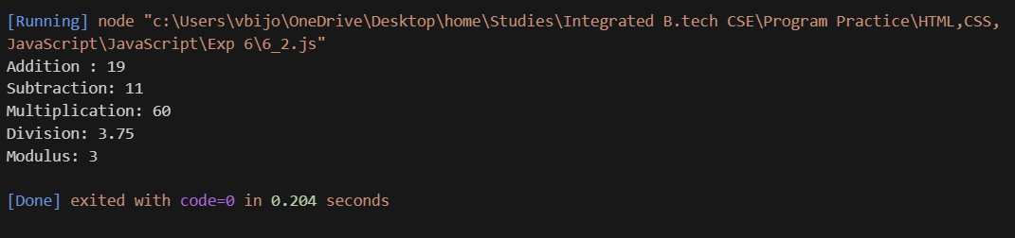
Output:
6.3
function calc(num1, num2, op) {
let r;
switch (op) {
case '+':
r = num1 + num2;
break;
case '-':
r = num1 - num2;
break;
case '*':
r = num1 * num2;
break;
case '/':
if (num2 === 0) {
return "Error: Division by zero is not allowed.";
}
r = num1 / num2;
break;
default:
return "Error: Invalid operator. Please use +, -, *, or /.";
}
return `The result of ${num1} ${op} ${num2} is ${r}`;
}
console.log(calc(10, 5, '+'));
console.log(calc(10, 5, '-'));
console.log(calc(10, 5, '*'));
console.log(calc(10, 5, '/'));
console.log(calc(10, 0, '/'));
console.log(calc(10, 5, '%'));
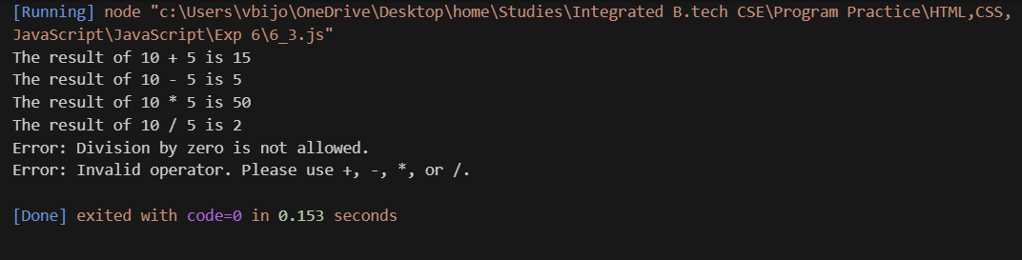
Output:
6.4. let age = prompt("Please enter your age:");
age = parseInt(age); // Convert the input string to a number

// Check voting eligibility
if (age >= 18) {
console.log("Eligible to vote");
} else {
console.log("Not eligible to vote");
}
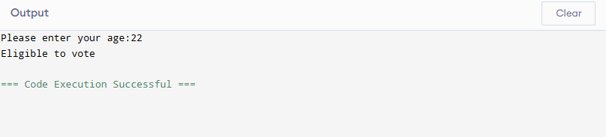
Output:

6.5. let mks = prompt("Enter your marks:");
mks = parseInt(mks);
if (mks >= 90) {
console.log("Grade A");
} else if (mks >= 75) {
console.log("Grade B");
} else if (mks >= 50) {
console.log("Grade C");
} else {
console.log("Fail");
}
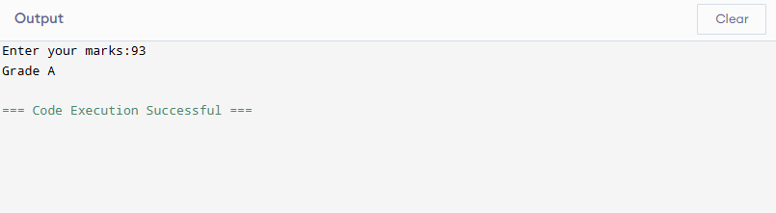
Output:
6.6. let dayNo = prompt("Enter a number (1-7):");
let dayNo = parseInt(dayNo); // Convert the input string to a number

let dayName;
switch (dayNo) { // Use the parsed integer
case 1:
dayName = "Monday";
break;
case 2:
dayName = "Tuesday";
break;
case 3:
dayName = "Wednesday";
break;
case 4:
dayName = "Thursday";
break;
case 5:
dayName = "Friday";
break;
case 6:
dayName = "Saturday";
break;
case 7:
dayName = "Sunday";
break;
default:
dayName = "Invalid input. Please enter a number between 1 and 7.";
}
console.log(dayName);
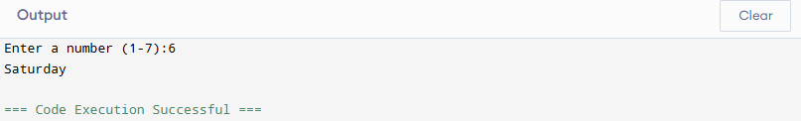
Output:
6.7. let n = prompt("Enter a number to check if it's even or odd:");
n = parseInt(n);
if (n % 2 === 0) {
console.log("Even number.");
} else {
console.log("Odd number.");
}
let n1 = prompt("Enter the first number:");
let n2 = prompt("Enter the second number:");
let n3 = prompt("Enter the third number:");
n1 = parseInt(n1);
n2 = parseInt(n2);
n3 = parseInt(n3);
let l;
if (n1 >= n2 && n1 >= n3) {
l = n1;
} else if (n2 >= n1 && n2 >= n3) {
l = n2;
} else {
l = n3;
}
console.log(`The largest number is ${l}.`);
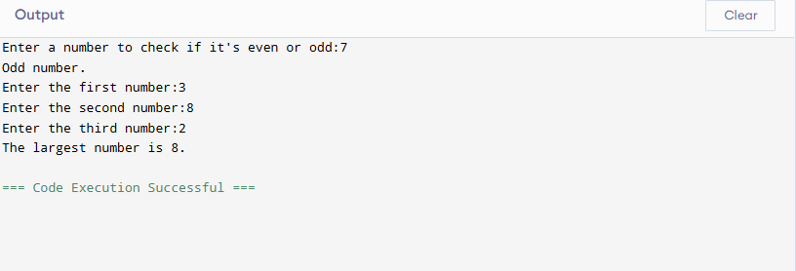
Output:

